1. 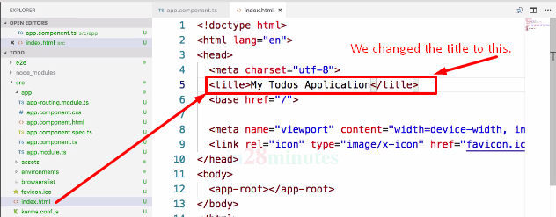
2. 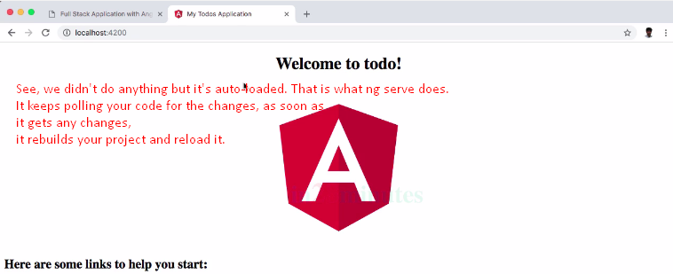
3. Let’s explore the command **ng lint**.
4. What is linting? Who is doing linting?
5. Linting is checking your code for code standards. Either your code passes the coding standards or doesn’t pass.
6. Let’s introduce a **coding standard violation**.
7. Command🡺 To open a file in Visual Studio Code.
8. 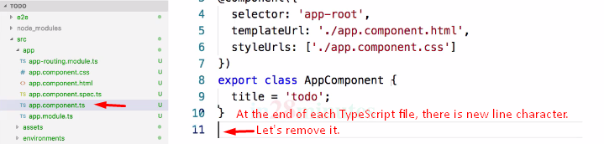
9. 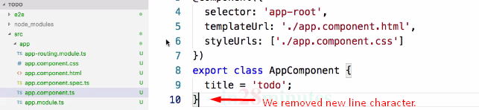
10. **Linting reporting error now.**  
    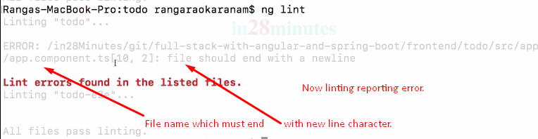
11. 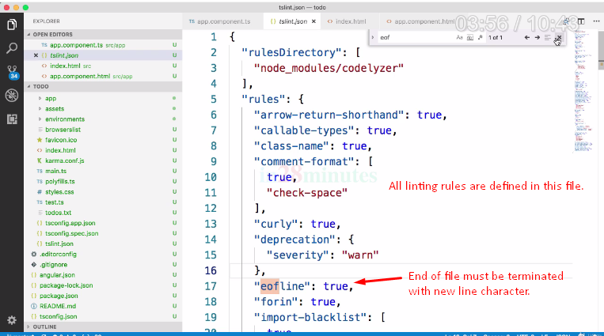

Command 🡺 Ng build

1. 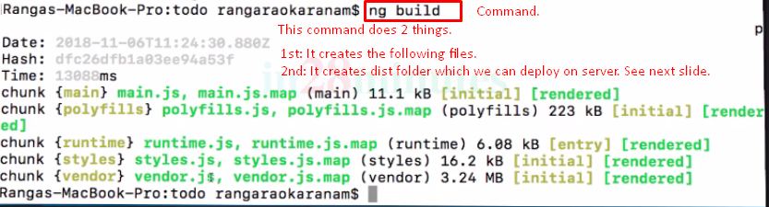
2. The good thing about the dist folder is that you can take this todo folder and put it behind any web server and you would be able to directly launch index.html file and run the entire app. So you don’t really need any of the other code which is present in src folder to launch these angular applications. Typically, when we deploy angular app to production, what we would do is we would execute **ng build** and we will take this folder **todo** which is generated and put it on the server.   
   So, this makes it easy to deploy applications to other environments. For example, test environments or production environment.

Command 🡺 Ng test

1. Used to run unit tests written for angular app.
2. **Specs**: In frontend, tests are called **specs**.
3. **Karma**: Used to run unit tests. **Jasmine**: Used to write unit tests.  
   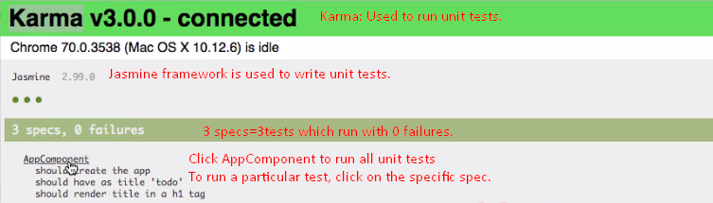
4. **Karma.confi.js**🡸 Configuration file for test runner.  
   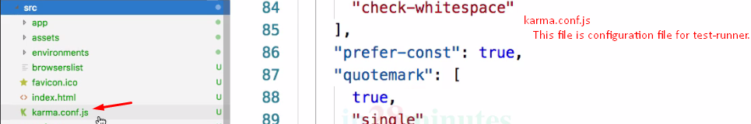
5. 
6. 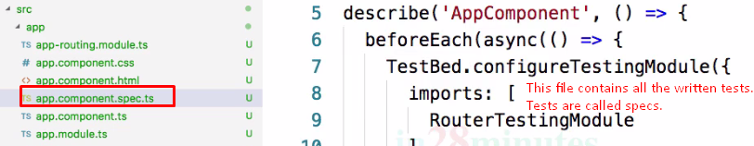
7. **Command**:CTRL/Cmd + C 🡺 To Kill the command in the command line.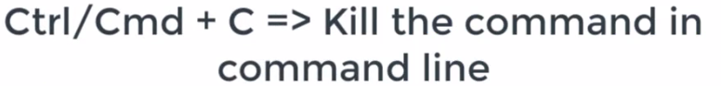

Command 🡺 ng e2e

1. E2e (End to End) test is much more than unit test.
2. “Unit test” tests individual components one at a time.
3. But with end to end test, we launch the entire app. 
4. We are launching the entire app with command ng e2e and running tests around it.
5. E2e tests are written using **Protector **
6. 
7. 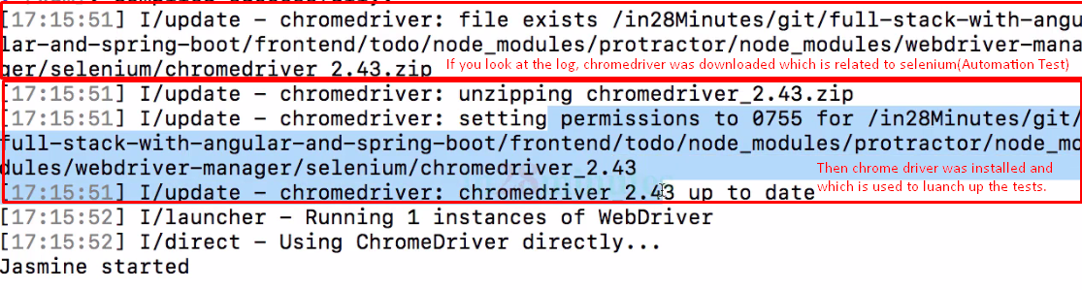
8. 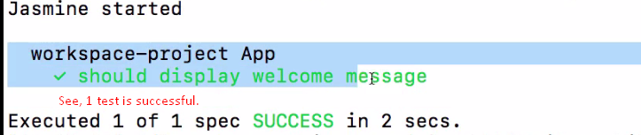
9. 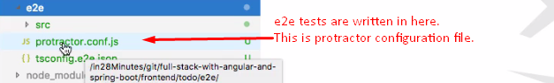
10. Angular.json🡸 